**After Cop26, community action initiatives in DMV show that local sustainbility education is upending the fashion industry**

*Representing a microcosm of the American fashion industry, sustainable fashion collectives in and around Washington, D.C., present optimistic change for minimizing individual carbon footprints.*

By Caroline Cliona Boyle

Six months on from the Cop26 climate summit in Glasgow, Scotland, sustainable fashion initiatives across the United States have heightened their efforts to promote eco-conscious consumption of fashion at the local level. In Washington, D.C., the result of these efforts is noticeable, and local organizations striving for sustainable change are engaging the community to think critically about individual consumption habits.

Last year, international climate deliberations came to a head at Cop26, the 2021 United Nations Climate Change Conference. At Cop26, world leaders from 120 nation states joined to map emissions reductions across many carbon-heavy sectors. At the summit, the [UNFCCC](https://unfccc.int/climate-action/sectoral-engagement/fashion-for-global-climate-action) emphasized the fashion industry as one of the top emitters, and brought to attention the need to align the industry with the goals of the Paris Agreement and the 2030 Agenda for Sustainable Development.

It’s widely known that the fast fashion industry accounts for [8-10% of global CO2 emissions](https://unece.org/forestry/press/un-alliance-aims-put-fashion-path-sustainability), which was revealed in a widely circulated UN report on sustainable fashion in 2020. On top of this, the industry produced [2.1 billion metric tons](https://www.mckinsey.com/industries/retail/our-insights/fashion-on-climate) of carbon in 2018 — the same quantity of greenhouse gases produced by Germany, the UK, and France combined, McKinsey reported.

The updated [UN Fashion Charter](https://unfccc.int/climate-action/sectoral-engagement/global-climate-action-in-fashion/about-the-fashion-industry-charter-for-climate-action) signed at COP26 became the acting legal document that binds the top fashion label signatories to comply with guidelines that will keep global emissions below a 1.5-degree increase. However, while the supranational policy was signed by [130 leading fashion companies](https://unfccc.int/climate-action/sectoral-engagement/global-climate-action-in-fashion/fashion-industry-charter-for-climate-action/participants-in-the-fashion-industry-charter-for-climate-action) in good faith, many community action organizations fear that the public may not connect with an international doctrine about sustainability.

In response to this dilemma, sustainable action initiatives built from the community-level up provide an alternative platform to educate individuals on climate-conscious fashion consumption.

Fashion Group International (FGI) is a global non-profit organization that hosts a total of 5,000 high profile members in the fashion industry across the world. In the wake of Cop26, the group has turned its eye toward sustainability, underscoring the importance of strengthened ties at the community-level to change consumption habits.

Regional Director of FGI in D.C. Shelby Davies-Sekle said that while discussions about the detrimental effects of fast fashion on the climate are far from new, Cop26 has instilled a revived sense of climate urgency that necessitates change within the fashion industry.

However, in referencing Cop26, “a big, huge project like that could be intimidating,” Davies-Sekle said. “It can be a gradual process. It's not like you need to snap your fingers and you're automatically the most sustainable brand on the planet.”

FGI is a global organization, but Davies-Sekle said what’s so special about the individual chapters is “that our members and everyone in this community is connected together to be able to share these learnings together,” she said. Ultimately, this dynamic is a catalyst for fashion industry representatives across the world to spread education of eco-conscious fashion at the local level.

**Sustainability collectives breed community support for second-hand fashion in the wake of Cop26**

Grassroots organizations in the DMV have become a stronghold for community support for fashion change. Currently, there are three primary collectives in the DMV that serve to promote ethical fashion by way of second-hand consumption: [The DC Sustainable Fashion Collective](https://dcsustainablefashioncollective.org/), [Tribute Collective](https://thisistribute.xyz/), and [CircleVibe DC](https://www.instagram.com/circlevibedc/), said Gabrielle Cleary, co-founder of the DC Sustainable Fashion Collective.

The desire to breed conversations about sustainability and second-hand fashion consumption within the D.C. fashion economy has attracted an organic community around it. Before founding the DC Sustainable Fashion Collective, “we knew that there are people around DC, Maryland and Virginia that are trying to bring in more sustainable practices with their fashion,” explained Cleary.

Since Cop-26, projections for the market value of the U.S. second-hand clothing industry are expected to [increase by 114%](https://www.statista.com/statistics/826162/apparel-resale-market-value-worldwide/) from 2021 to 2025, according to data collected by ThredUp. The revenue incurred from this market value increase will [amount to $244 billion](https://www.statista.com/statistics/1275339/resale-market-value-online-offline/) by 2025, Mercari projected.

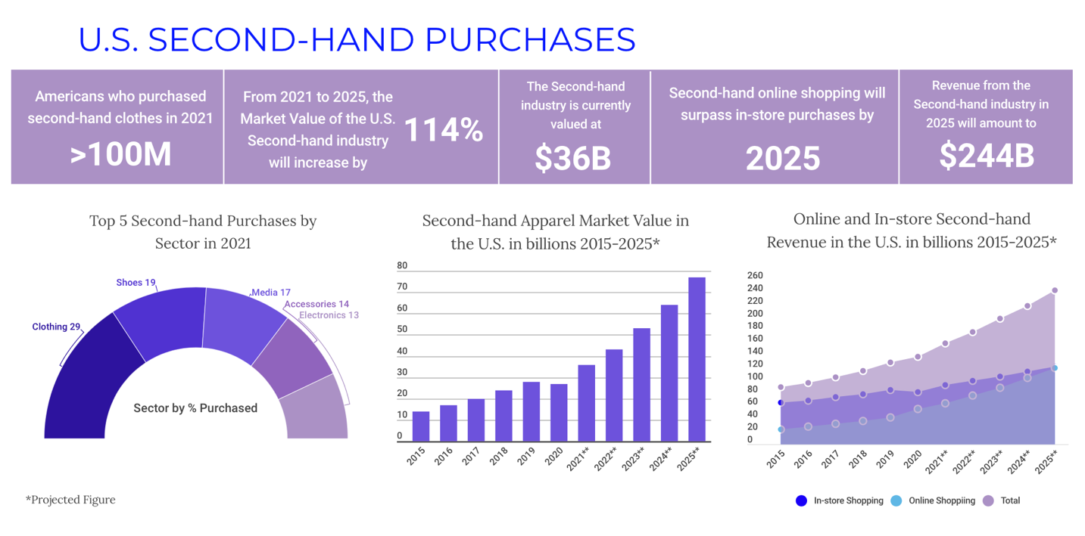

Additionally, of all of the categories of second-hand products consumed by Americans in 2021, clothing presented the highest percentage. In total, [29% of Americans](https://www.statista.com/forecasts/997103/second-hand-purchases-by-category-in-the-us) purchased second-hand clothing — a figure which amounts to over 100 million individuals, ThredUp measured.

Second hand trends within the DMV most certainly meet upward trajectory of sustainable purchases at the national level, Cleary expained. As a D.C. native, Cleary said the consumption of second-hand within the DMV has similarly exploded in popularity over the past 10 years.

Growing popularity around vintage, second-hand, and sustainability across the country ultimately inspired her to co-found the DC Sustainable Fashion Collective in 2018. Through formal conferences and informal meet-ups, the collective “wants to keep it organized, but also spread the information about sustainable fashion, make it available, and then also include be inclusive in the conversation,” she said.

**Circlevibe DC and Tribute: Grassroots collectives bring humanity to the sustainable fashion movement**

Juliana Jaramillo is the founder of Circle Vibe DC, a sustainable fashion collective based in Washington, D.C., that leverages social media to educate the public on second-hand fashion. Similar to Tribute, this organization encourages D.C. locals to buy second-hand through swap-shops. The collective also holds information sessions about the many negative affects of the fast fashion industry has on exploited garment workers in addition to the industry’s contribution to the climate crisis.

Jaramillo’s inspiration for creating Circevibe DC began out her use of online second-hand seller Depop. Cop26 onwards, trends toward second-hand consumption in the U.S. are projected to increase from [$160 billion to $244 billion](https://www.statista.com/statistics/1275339/resale-market-value-online-offline/), according to Mercari.

Jaramillo says the casual nature of these meet-ups promoted by Circlevibe have made education on the stark realities of climate change a more approachable conversation on changing individual habits.

“How do you make this topic less heavy, more casual conversation, and more about teaching people about labor, and how the fashion industry affects people in other countries?”she asks. Ultimately, it’s about creating “an environment that is like very apt for people to really absorb this information in a more casual way, in a conversational way,” said Jaramillo.

One of the primary intiatives that Jaramillo runs at Circle Vibe is the creation of a capsule wardrobe, which is a highly curated set of clothing items that limits the need to consume fashion products elsewhere, she said. At the swap-shops, fashion-savy locals can trade clothes between each-other, allowing people to indulge in their changing taste in fashion, without enlargening their carbon footprint.

Tangential to the swap-shops organized by Circlevibe DC is the swap-shops promoted by the Washington-based sustainable fashion collective Tribute. Similar to Circlevibe DC, Tribute is an organization that uses organic connections within the DMV’s fashion industry to engage in conversations around sustainability.

Joelle Firzli, one of the founders of Tribute Collective, said that in continuing the conversation of sustainability within D.C.’s fashion space, engaging with the community whilst maintainting inclusivity is tenfold. At the policy level, Tribute advocates for intersectional environmentalism at the helm of their conversation on second fashion.

Intersectional environmentalist advocate Leah Thomas [coined the term](https://www.marieclaire.com/politics/a36176067/what-is-intersectional-environmentalism/) in 2017 with efforts to create a movement that supports eco-conscious behaviors whilst recognizing the need to resolve inequities in the environmental space. In the wake of Cop26, Firlzi said including intersectional environmentalism within Tribute’s conversation on sustainable fashion is about “bringing people from different backgrounds together and realizing that they can meet and talk about creating a new story around fashion.”

Together, the DC Sustainable Fashion Collective, Tribute, CircleVibeDC and Fashion Group International demonstrate that national trends toward second-hand fashion can be realized at the local level. In the wake of Cop26, these intiatives foster optimistic outlooks that organic ties bred at the local level will create large-scale change within the American fashion industry in the coming years.

**Bibliography**

<https://unece.org/forestry/press/un-alliance-aims-put-fashion-path-sustainability>

<https://www.mckinsey.com/industries/retail/our-insights/fashion-on-climate>

<https://unfccc.int/climate-action/sectoral-engagement/global-climate-action-in-fashion/about-the-fashion-industry-charter-for-climate-action>

<https://unfccc.int/climate-action/sectoral-engagement/global-climate-action-in-fashion/fashion-industry-charter-for-climate-action/participants-in-the-fashion-industry-charter-for-climate-action>

<https://www.marieclaire.com/politics/a36176067/what-is-intersectional-environmentalism/>

**Sources for Visuals**

Top 5 Purchases by Sector in 2021

* **ThredUp/Global Data:** <https://www.statista.com/forecasts/997103/second-hand-purchases-by-category-in-the-us>

Second-hand apparel market value 2015-2025 in billions

* **ThredUp/Global Data:** <https://www.statista.com/statistics/826162/apparel-resale-market-value-worldwide/>

Online/In-person second-hand shopping trends 2015-2025

* **Mercari/Global Data:** <https://www.statista.com/statistics/1275339/resale-market-value-online-offline/>

**Interviews Conducted**

Shelby Davies-Sekle:Regional Director of Fashion Group International DC, 703-568-3135, [shelbyeds@gmail.com](mailto:shelbyeds@gmail.com) (Zoom)

Gabrielle Cleary: Co-founder of DC Sustainable Fashion Collective, 240-702-5137, [clarygabby@gmail.com](mailto:clarygabby@gmail.com) (Phone call)

Juliana Jaramillo: Co-founder of Circlevibe DC, [julianajaramillor@gmail.com](mailto:julianajaramillor@gmail.com) (Zoom)

Joelle Firzli: Co-founder of Tribute Collective, 917-971-3804, [info@thisistribute.com](mailto:info@thisistribute.com) (Phone call)